1.EC2 Instance creation:
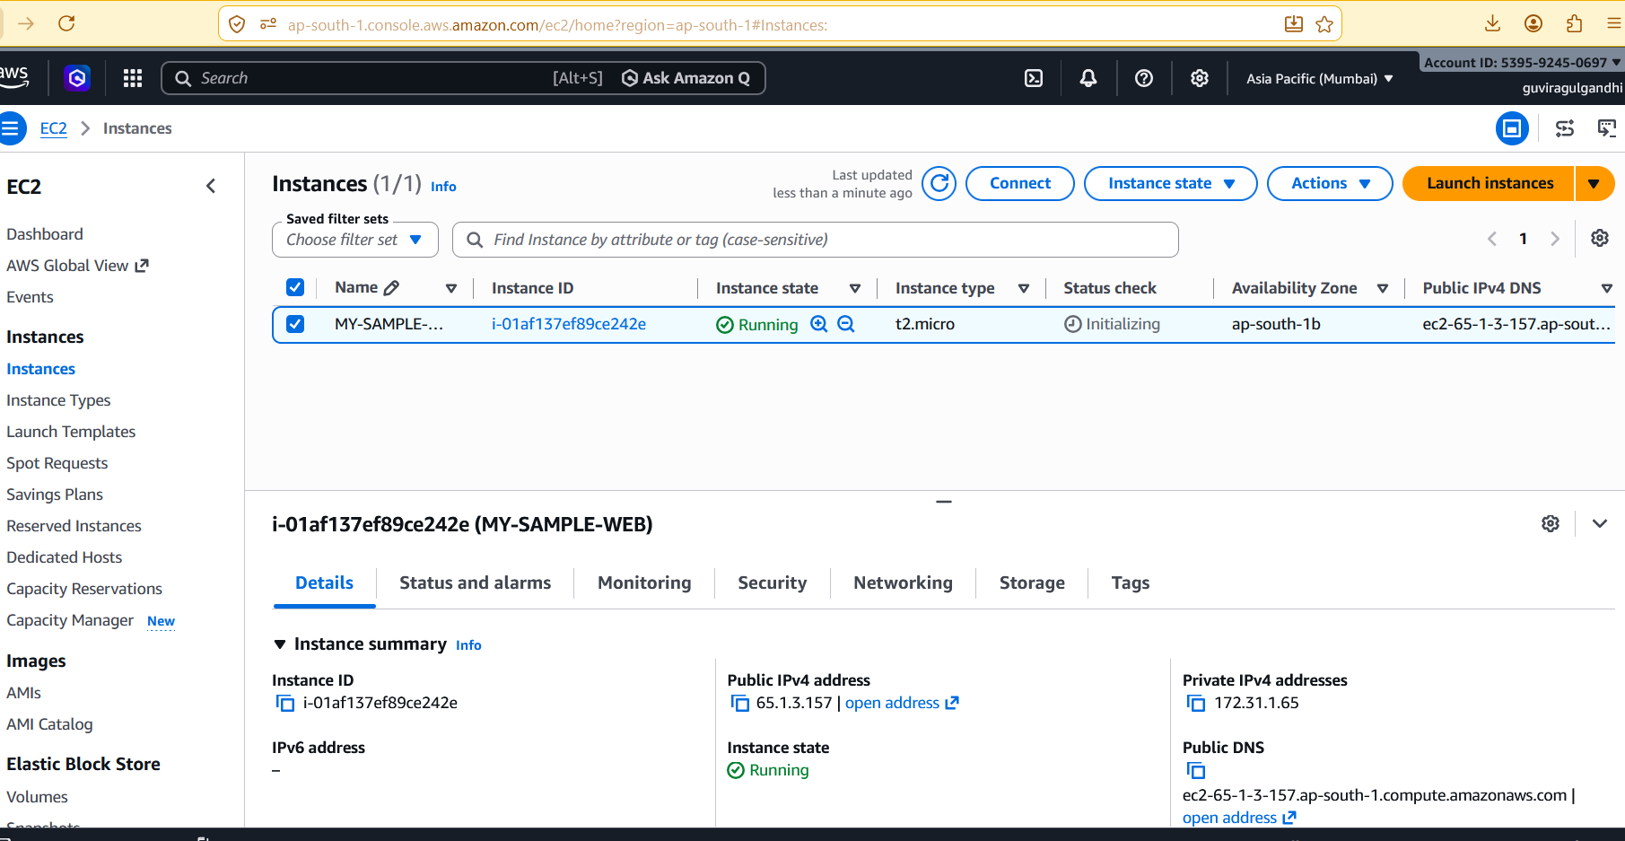
2.Install DOCKER on the EC2 Instance:
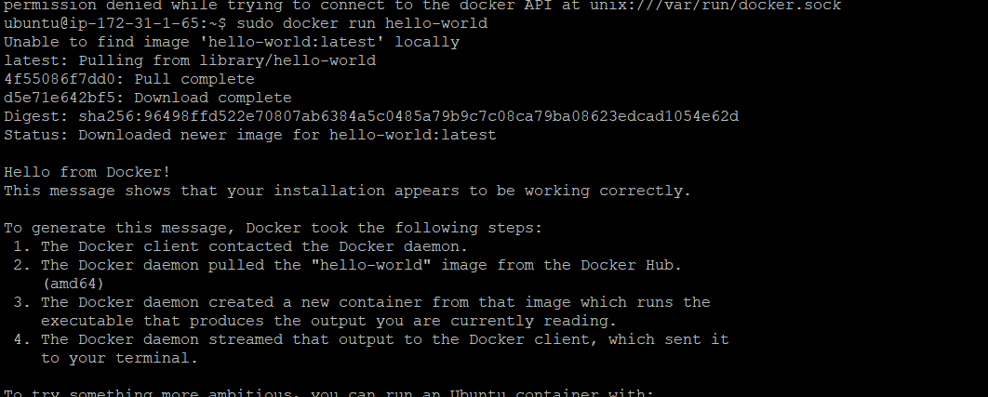
3.Nginx Installation on the Ec2:
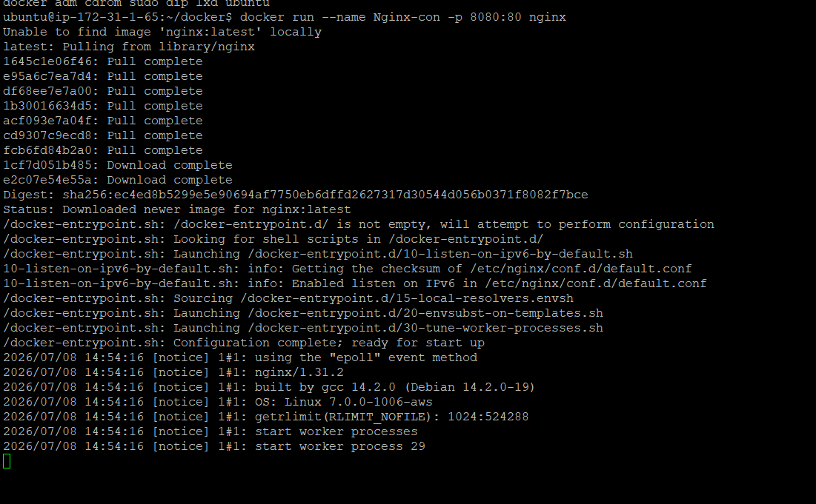
4.NGINX Validation on the browser using public ip:
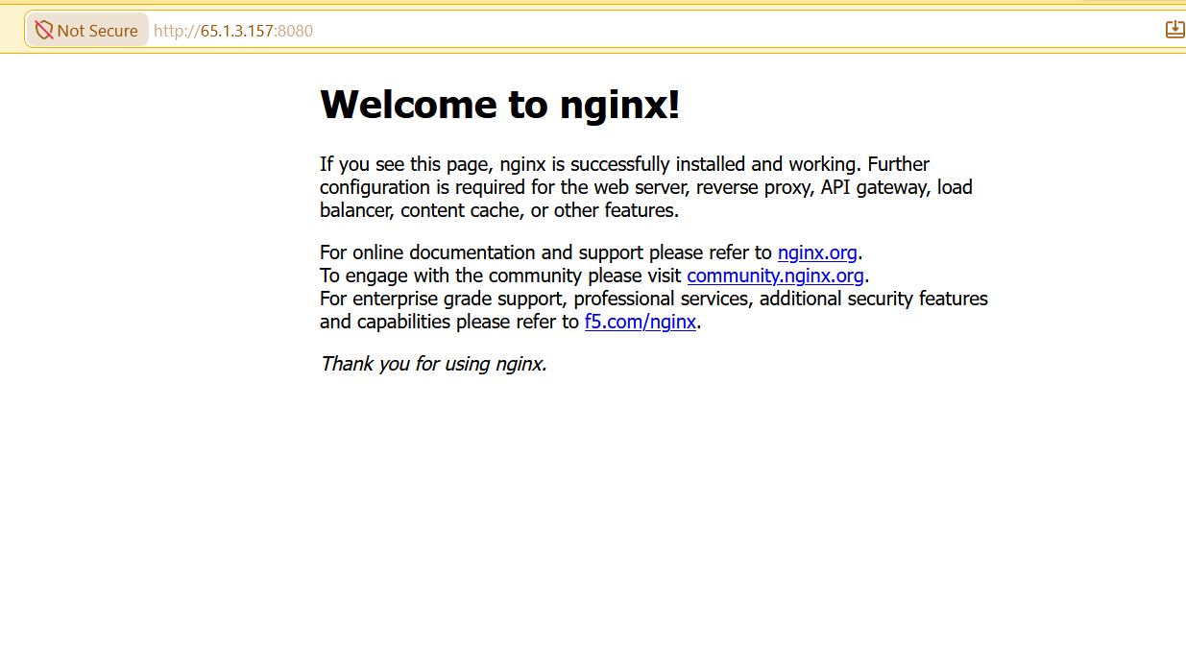
5.Docker File created for Custom-Nginx Image:

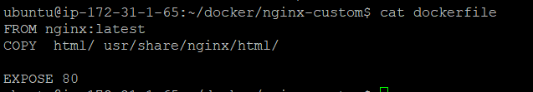
6.NGINX CUSTOM IMAGE EXPOSED TO SAME PORT 8080:
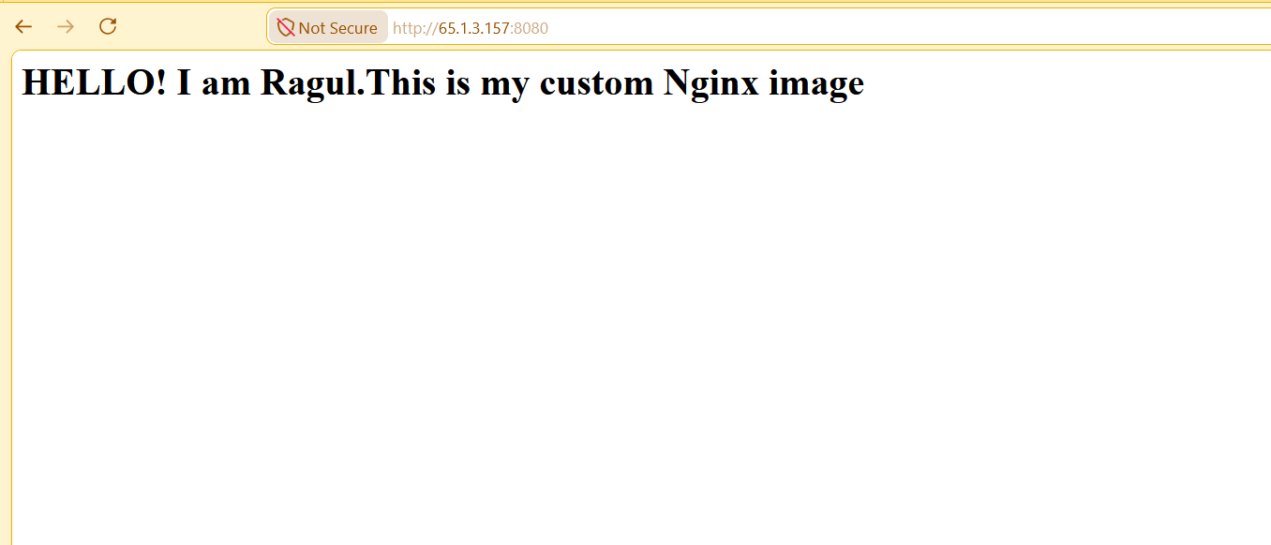
7.Docker Compose file:
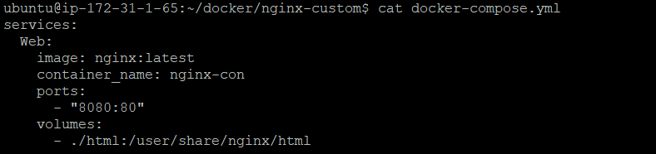
8.Container created with Docker compose:
